00000000000000000000000000000000000000000000000000000000000000000000000000000000000000000000000000000000000000000000000000

JC Rupe

Date: **January 17, 2017**

Version: **1.0.0.1**



**Project Eden:**

*Local Dispatch Application*

**IT Project Management Office**

Document Revisions

|  |  |  |
| --- | --- | --- |
| Date | Version Number | Document Changes |
| 2016/12/27 | 1.0.0 JC | Document initial creation/completion. |
| 2017/01/03 | 1.0.0 JC | Edited a small amount of the wording. Section 1.1. |
| 2017/01/17 | 1.0.0.1 JC | Added document name to footer. |
|  |  |  |
|  |  |  |
|  |  |  |
|  |  |  |
|  |  |  |
|  |  |  |

Contents

1 Local Dispatch Application 3

1.1 Important Information 3

1.2 Navigate to Local Dispatch Application 3

1.3 Features 4

1.3.1 Selection Criteria Panel 4

1.3.2 Service Activities Panel 5

1.3.3 Dispatch/Resource Panel 6

1.3.3.1 Assign Resources Tab 6

1.3.3.2 Manage Teams Tab 9

1.3.3.3 Manage Resources Tab 10

2 General Resource Management 11

2.1 Update Utilization Thresholds – Assign Resources Tab 11

2.2 Manage Teams 13

2.2.1 Add a Team – Manage Teams Tab 13

2.2.2 Edit a Team – Manage Teams Tab 14

2.2.3 Deactivate a Team – Manage Teams Tab 15

2.3 Manage Resources 16

2.3.1 Add Resource Downtime – Manage Resources Tab 16

2.3.2 Deactivate Resource Downtime – Manage Resources Tab 17

3 Service Activity Management 18

3.1 Navigate to View/Edit a Service Activity 18

3.1.1 Locate Desired Service Activity 18

3.1.2 Select Desired Service Activity 18

3.2 Edit Service Activity 19

3.3 Add Resources to Service Activity 20

3.4 Remove Resource from Service Activity 22

3.5 View and Add Call Logs 23

3.6 View Documents 24

# Local Dispatch Application

This document explains how to use the Local Dispatch application.

## Important Information

* The preferred browser to use is Microsoft Explorer, although, Chrome and Firefox should also work.

## Navigate to Local Dispatch Application

1. Navigate to the Local Dispatch application.
   1. See your supervisor if you don’t have this link.
2. The Local Dispatch window will open and display.
   1. Displayed are 3 panels.
      1. Selection Criteria Panel – The top panel is for setting the Selection Criteria.
      2. Service Activities panel – The left panel displays Service Activities.
      3. Dispatch/Resource Panel – The large right panel is for setting up the Dispatch of the Service Activity.

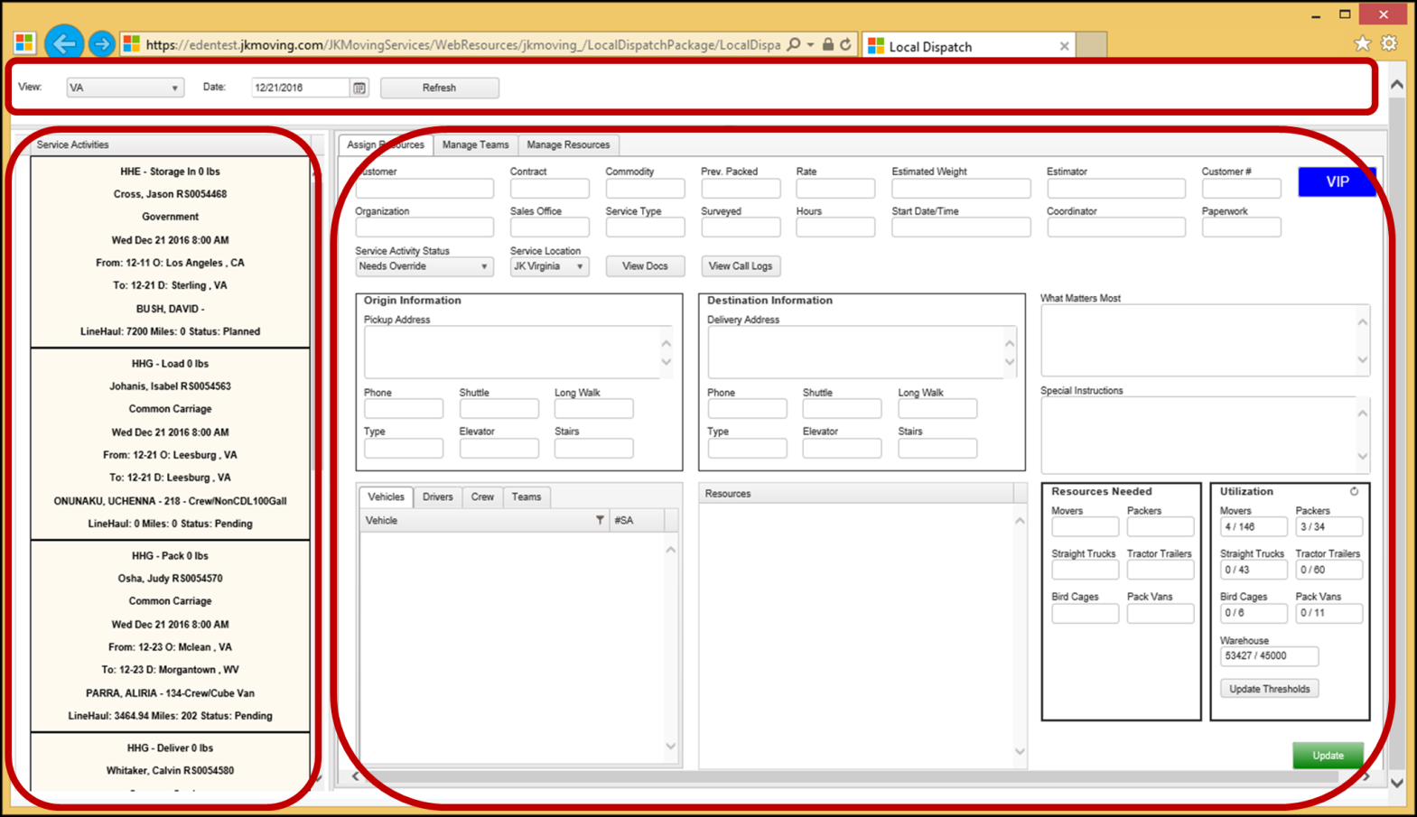

## Features

### Selection Criteria Panel

Set the criteria for retrieving the Service Activities to be dispatched. These selections determine which Service Activities appear in the Service Activities panel.

1. Select criteria.
   1. **View –** Select the local origin/destination to be viewed.
      1. Options are:
         1. VA – Virginia, including Washington DC
         2. MD – Maryland
         3. VA/MD – Virginia, Washington DC and Maryland
         4. SH – Short Haul
         5. OT – Off Terminal
         6. ALL – All the will be displayed.
   2. **Date –** Select the expected date of the Service Activity.
2. The **“Refresh”** button will refresh the “Service Activities” panel to current criteria selections.
   1. **Note: he** Dispatch/Resource Panel display will remain the same as the last Service Activity selection. You must select a Service Activity from the Service Activities panel to refresh the data in the Dispatch/Resource Panel.

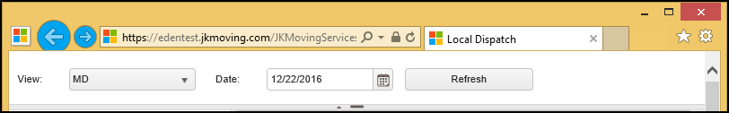

### Service Activities Panel

This panel displays the Service Activities that meet the criteria selected in the Selection Criteria panel. Each Service Activity is displayed in a box that contains summary information about the Service Activity.

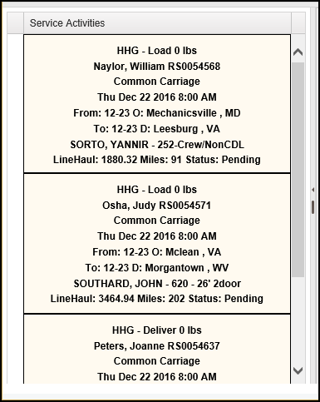

1. Service Activity summary information displayed.
   1. Service Activity name (shortened)
   2. Weight
   3. Contact Name
   4. Service Activity Number
   5. Contract
   6. Scheduled Start date & time for the Service Activity
   7. Origin
   8. Destination
   9. Summary of Resources
      1. Driver/Foreman is listed
      2. Vehicle
   10. LineHaul
   11. Miles
   12. Status
2. When the Service Activity in this panel is selected, it’s Dispatch information is populated and displayed in the Dispatch/Resource Panel.
   1. **Note:** Only one-at-a-time may a Service Activity be selected and viewed.

### Dispatch/Resource Panel

The Dispatch/Resource Panel serves two functions. First, it displays information and provides a way for the Dispatcher to perform Service Activity Management. Second, it provides a way for the Dispatcher to perform General Resource Management.

1. The Dispatch/Resource Panel consists of 3 tabs.
   1. Assign Resources tab.
   2. Manage Teams tab.
   3. Manage Resources tab.

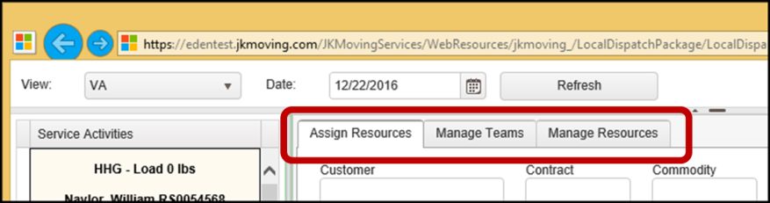

#### Assign Resources Tab

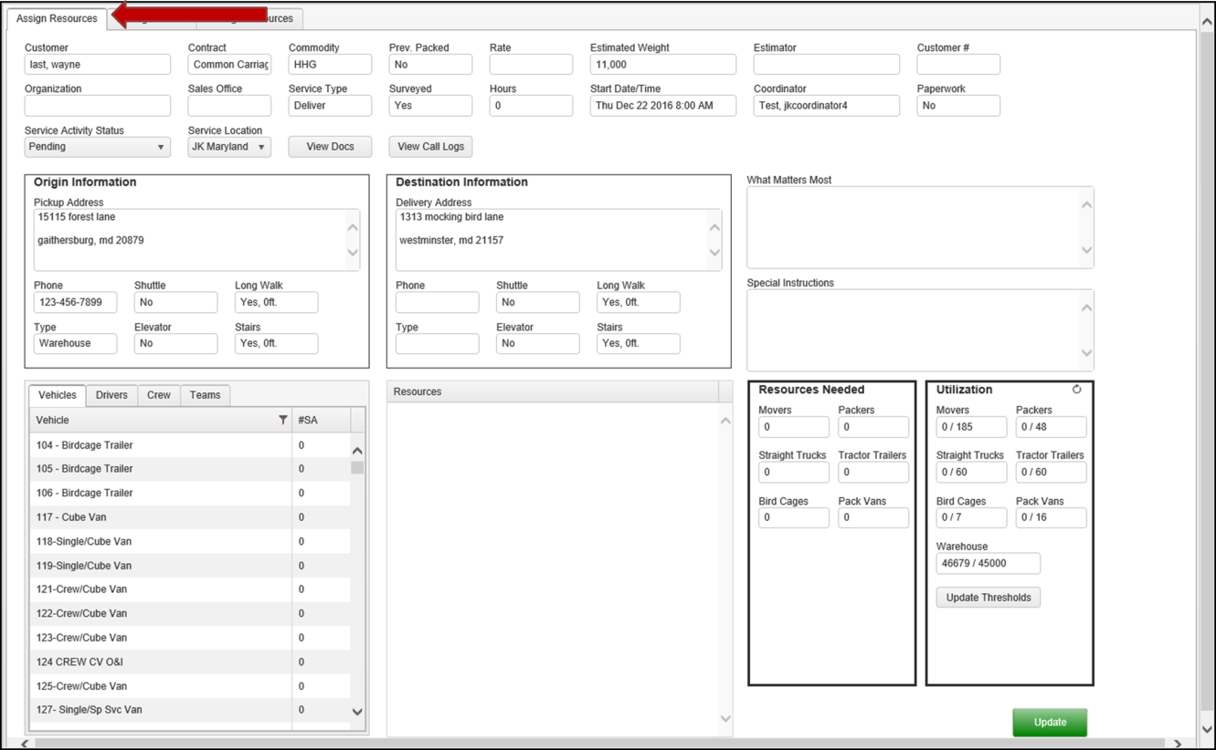

1. Service Activity information displayed only. (Not editable from within Local Dispatch.)
   1. **Customer –** The Contact/Customer full name.
   2. **Contract –** The contracting agency or customer’s employer.
   3. **Commodity**
   4. **Prev. Packed**
   5. **Rate**
   6. **Estimated Weight**
   7. **Estimator**
   8. **Customer #**
   9. **Organization**
   10. **Sales Office**
   11. **Service Type**
   12. **Surveyed**
   13. **Hours**
   14. **Start Date/Time**
   15. **Coordinator**
   16. **Paperwork**

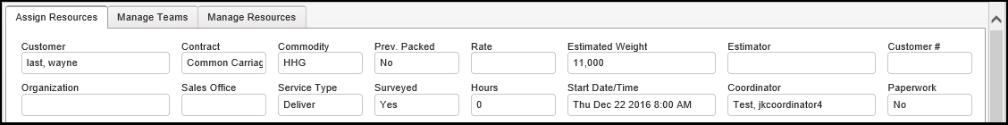

* 1. **Origin Information –** Address, Phone, Shuttle, Long Walk, Type, Elevator and Stairs.
  2. **Destination Information –** Address, Phone, Shuttle, Long Walk, Type, Elevator and Stairs.

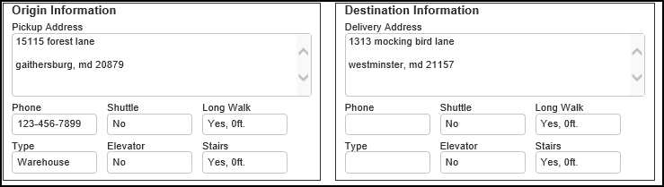

1. **View Docs button –** Selecting this button takes you to see documents associated with the Move.



1. **View Call Logs button –** Selecting this button takes you to see the call logs associated with the Service Activity.



1. Editable Service Activity information.
   1. **What Matters Most**
   2. **Special Instructions**

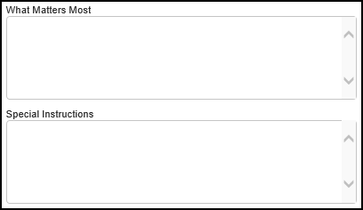

* 1. **Service Activity Status**
  2. **Service Location**



1. **Available Resources panel**. This panel displays **Vehicles**, **Drivers**, **Crew** and **Teams** available to be assigned to the Service Activity.

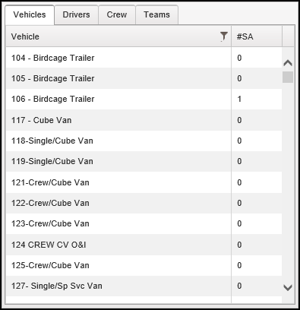

1. **Resources panel**. Contains all the resources selected to participate in the Service Activity.

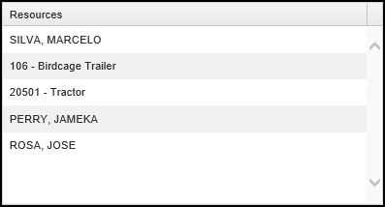

1. **Resources Needed**. Displays the desired resources for the Service Activity. **Movers**, **Packers**, **Straight Trucks**, **Tractor Trailers**, **Bird Cages** and **Pack Vans**.
2. **Utilization**. Displays the resource utilization. **Movers**, **Packers**, **Straight Trucks**, **Tractor Trailers**, **Bird Cages** and **Pack Vans**.
   1. **Update Thresholds button -** Selecting this button takes you to the “Utilization Thresholds” page.

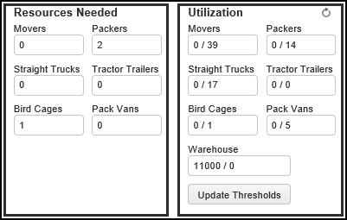

1. **Update button –** Selecting this button will save all changes and updates to the Service Activity.

#### Manage Teams Tab

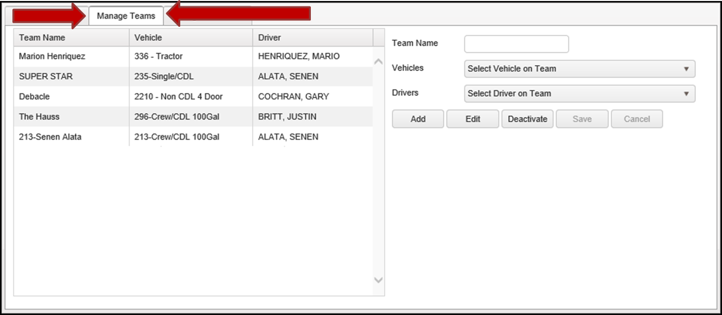

1. **Table of Teams panel** – The left panel contains a table of established Teams.
   1. **Team Name –** The name assigned to the Team when it is created.
   2. **Vehicle –** The vehicle that is assigned to the Team.
   3. **Driver –** The person assigned to drive the Team vehicle.
2. **Team Action panel** – The right panel contains the data entry fields for creating Teams and the action buttons.
   1. **Team Name –** The name assigned to the Team when it is created.
   2. **Vehicles –** A vehicle selection list.
   3. **Drivers –** A driver selection list.
   4. **Add button –** Used to add new Teams.
   5. **Edit button –** Used to edit an existing Team.
   6. **Deactivate button –** Used to deactivate an existing Team.
   7. **Save button –** This button is used to save a Team after editing. It becomes active after the “Edit” button is selected.
   8. **Cancel button –** This button is used to cancel the editing of a Team. It becomes active after the “Edit” button is selected.

#### Manage Resources Tab

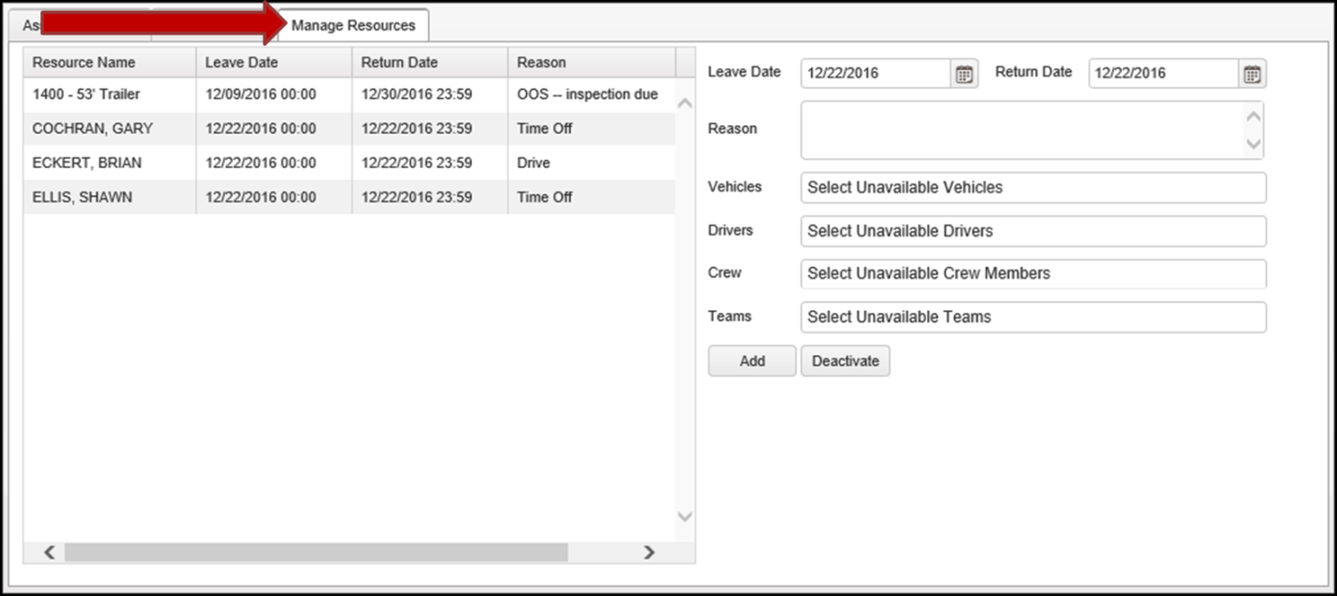

1. **Table of Resources panel** – The left panel contains a table of established Resources.
   1. **Resource Name –** The name assigned to the Resource when it is created.
   2. **Leave Date –** The first date of the Resources downtime.
   3. **Return Date –** The first date the Resource will be available.
   4. **Reason –** The reason for the Resources downtime.
2. **Resource Action panel** – The right panel contains the data entry fields for adding Resource downtimes and the action buttons.
   1. **Leave Date –** The first date of the Resources downtime.
   2. **Return Date –** The first date the Resource will be available.
   3. **Reason –** The reason for the Resources downtime.
   4. **Vehicle –** The vehicle Resource that will be down.
   5. **Driver –** The driver Resource that will be down.
   6. **Crew –** The Crew Resource that will be down.
   7. **Team –** The Team Resource that will be down.

# General Resource Management

## Update Utilization Thresholds – Assign Resources Tab

It is assumed that you are already in the Local Dispatch application. Utilization Thresholds are not part of the Service Activity, so whether a Service Activity is selected or not doesn’t matter.

* Utilization Thresholds are set for 6 months out.
* The current week, which is shown, runs Sunday through Saturday.

1. Select the “Assign Resources” tab.
2. Select the “Update Thresholds” button, in the Utilization panel. 
3. The “Utilization Thresholds” window will display.

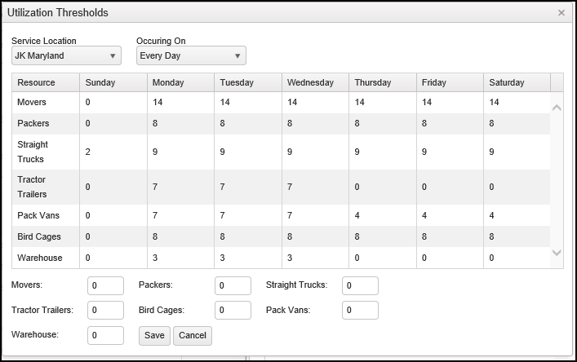

1. Select the “Service Location”.
   1. Options are:
      1. JK Maryland
      2. JK Virginia
2. Select which “Occurring On” block of day(s) the new utilization thresholds are to be set.
   1. **Caution:** When selecting the “Occurring On” value, remember that the entire block of values is changed to what is entered for each resource. If you want to change more than one “Occurring On” block, be careful of the order you select the blocks to make changes.
      1. ***Block update:*** All the values for resources, that are in the data entry fields, will update the block selected. For example: If you only want to increase the Movers for Monday then you must also enter the existing values for the other Resources, otherwise the other Resources values will be set to the 0 default value.
      2. ***Selection order:*** For example, you change Monday and Wednesday values, and then change Weekdays values. What will occur is that the values entered for Weekdays will overwrite your Monday and Wednesday values. The way to do it correctly is to change Weekdays values first and then go back in to change Monday and Wednesday.
   2. Options are:
      1. Every Day – **This will set the values starting with today going forward. Using this option can be confusing. It’s recommended that you only use it if you thoroughly understand what it will do and what you will see in the “Utilization Thresholds” window.
      2. Weekdays – This will set the values starting with the Monday of the current week.
      3. Weekends – This will set the values starting with Sunday of the current week.
      4. Monday
      5. Tuesday
      6. Wednesday
      7. Thursday
      8. Friday
      9. Saturday
      10. Sunday
3. Enter new numbers for the desired resources.
   1. **Note:** Read the caution and its notes found above.
   2. Movers
   3. Packers
   4. Straight Trucks
   5. Tractor Trailers
   6. Bird Cages
   7. Pack Vans
   8. Warehouse
4. Select the “Save” button.
5. The “Utilization Thresholds” page will disappear.
6. Select the “Update Thresholds” button to verify changes.

## Manage Teams

A Team is a specific Driver teamed up with a specific Vehicle. The Driver and the Vehicle are a Team. Team Management is not part of the Service Activity, so whether a Service Activity is selected or not doesn’t matter.

### Add a Team – Manage Teams Tab

It is assumed that you are already in the Local Dispatch application.

1. Select the “Manage Teams” tab.
2. Enter appropriate values into the right Team Action panel.
   1. Enter a “Team Name”.
   2. Select a “Vehicle” to add to the Team.
   3. Select a “Driver” for the Team.

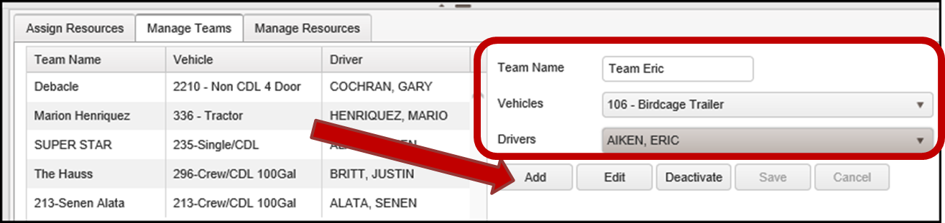

1. Select the “Add” button.
2. The new Team will now be displayed in the left Table of Teams panel.

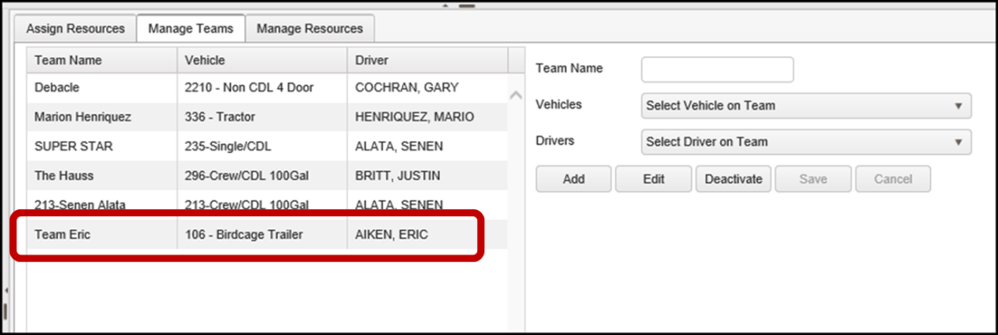

### Edit a Team – Manage Teams Tab

It is assumed that you are already in the Local Dispatch application.

1. Select the “Manage Teams” tab.
2. Select a Team to edit, in the Table of Teams panel.
3. Select the “Edit” button.

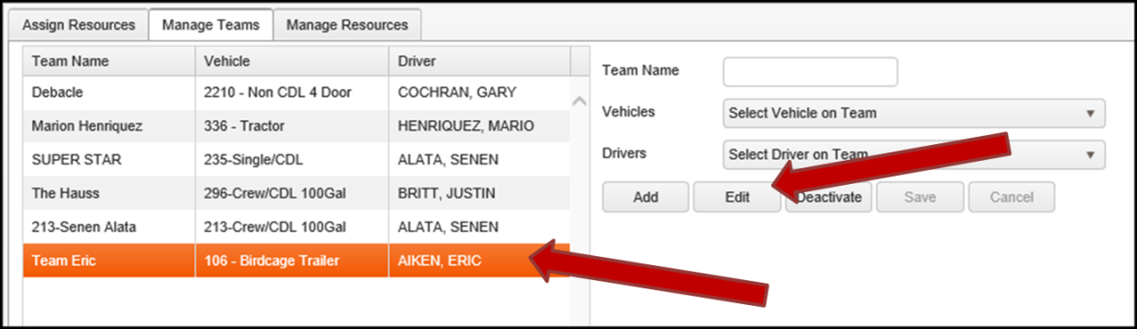

1. The editable Team information will display in the Team Action panel.

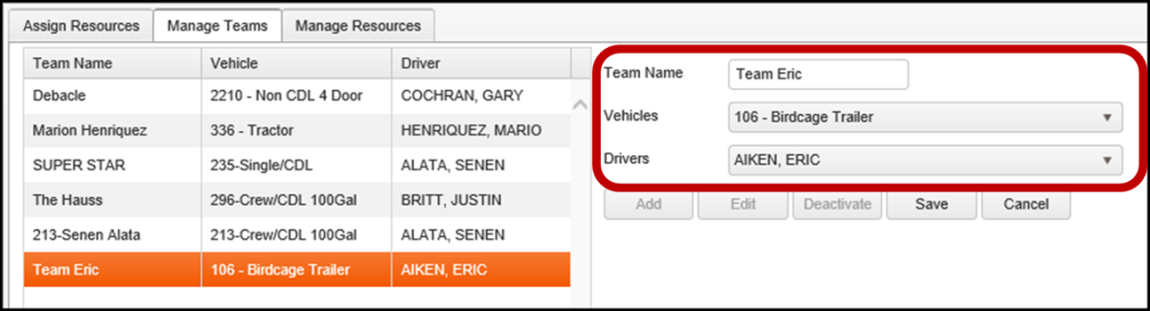

1. Make desired changes.
2. Select the “Save” button.
3. The edited Team record is now displayed in the Table of Teams panel.

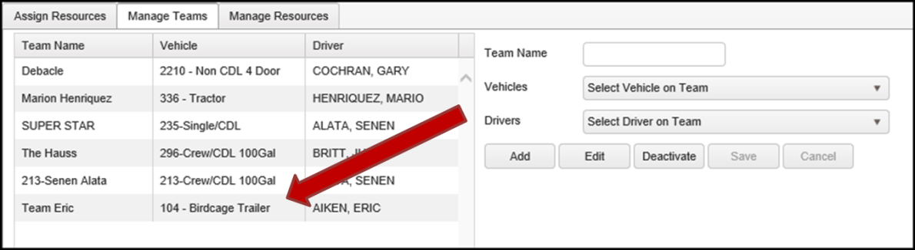

### Deactivate a Team – Manage Teams Tab

It is assumed that you are already in the Local Dispatch application.

1. Select the “Manage Teams” tab.
2. Select a Team to deactivate, in the Table of Teams panel.
3. Select the “Deactivate” button.

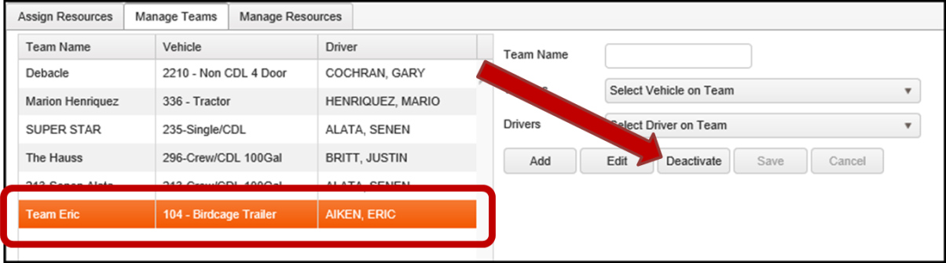

1. A confirmation window will display.
2. Select the “Confirm” button.

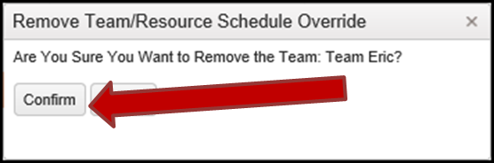

1. The deactivated Team record is now gone from the Table of Teams panel.

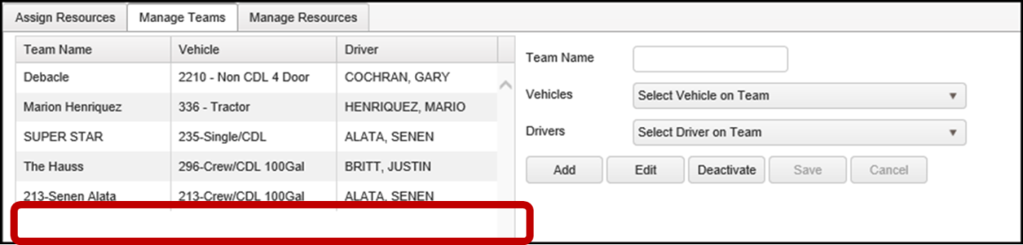

## Manage Resources

Resource Management is not part of the Service Activity, so whether a Service Activity is selected or not doesn’t matter.

### Add Resource Downtime – Manage Resources Tab

It is assumed that you are already in the Local Dispatch application.

1. Select the “Manage Resources” tab.
2. Enter appropriate values into the right Resource Action panel.
   1. Enter a “Leave Date”.
   2. Enter a “Return Date”.
   3. Enter a “Reason” for the downtime.
   4. Select one or more Resources.
      1. **Note:** Multiples may be selected as long as their downtime Dates and Reason are the same.
      2. **Note:** More than one Resource may be selected for each type of Resource.
      3. Select a “Vehicle” that will be down.
      4. Select a “Driver” that will be down.
      5. Select a “Crew” that will be down.
      6. Select a “Team” that will be down.
3. Select the “Add” button.

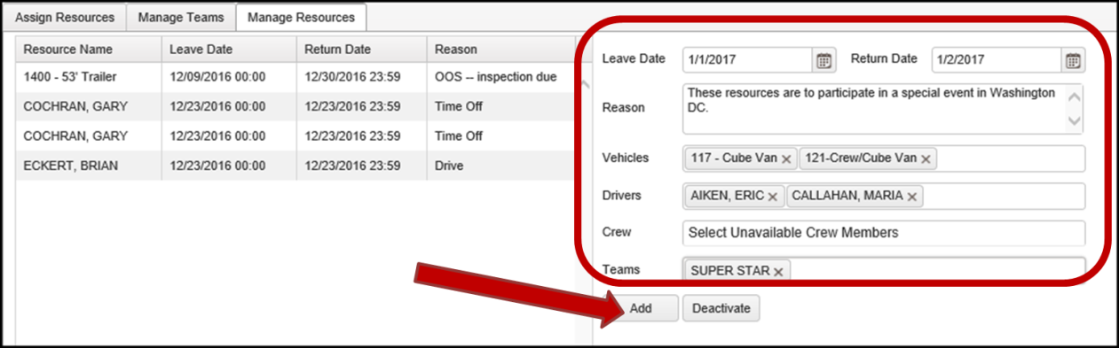

1. The Resource downtimes are now displayed in the Table of Resources panel.
   1. **Note:** There are six Resources added because we added two Vehicles, two Drivers and one Team. The Team consists of a Driver and a Vehicle. The total is six, with three Drivers and three Vehicle resources added for downtime.

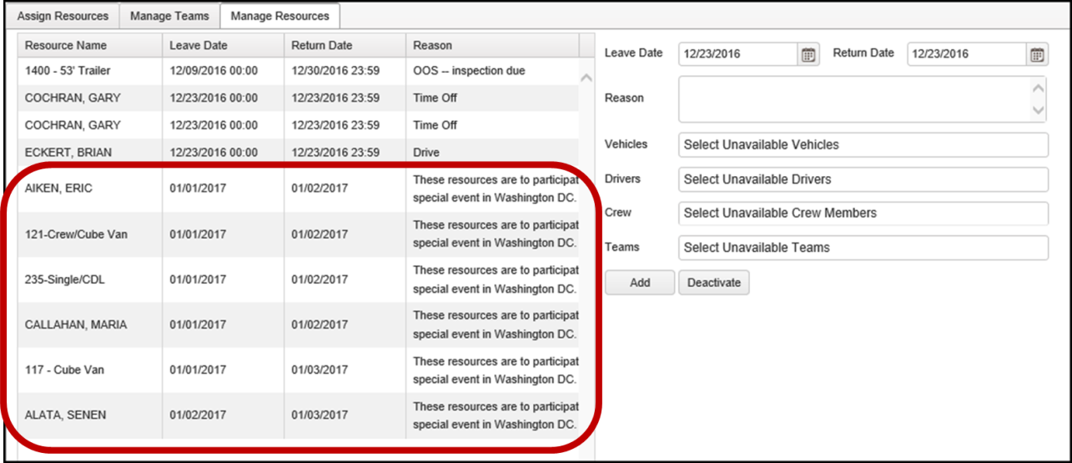

### Deactivate Resource Downtime – Manage Resources Tab

It is assumed that you are already in the Local Dispatch application.

1. Select the “Manage Resources” tab.
2. Select a Resource to deactivate, in the Table of Resources panel.
3. Select the “Deactivate” button.

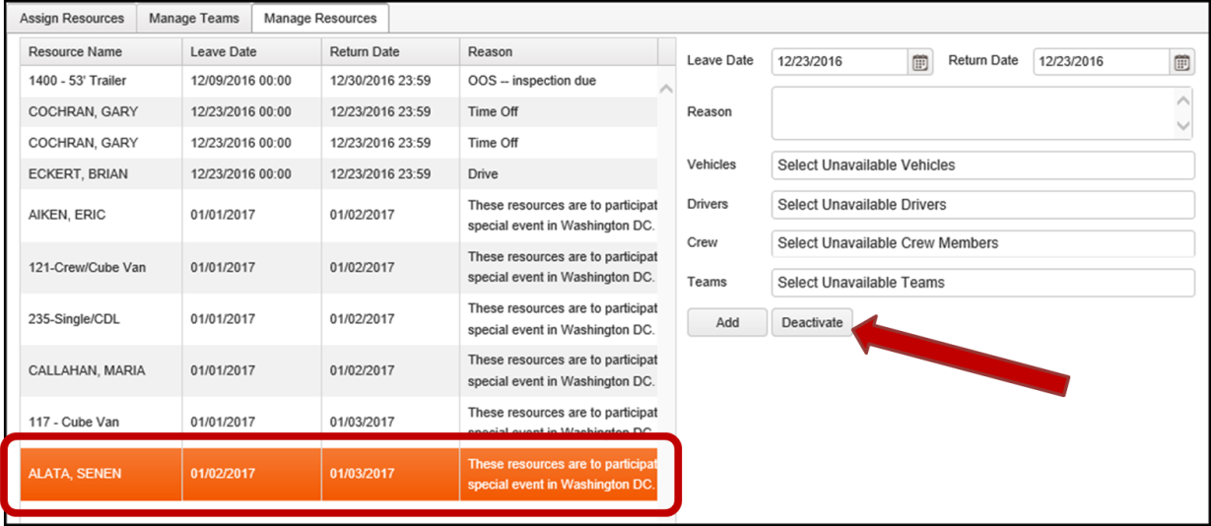

1. A confirmation window will display.
2. Select the “Confirm” button.

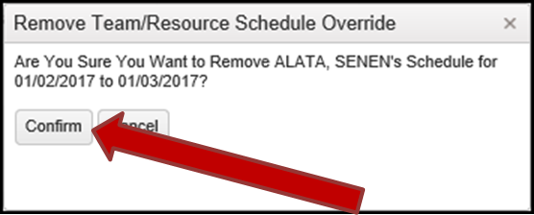

1. The deactivated Resource record is now gone from the Table of Resources panel.

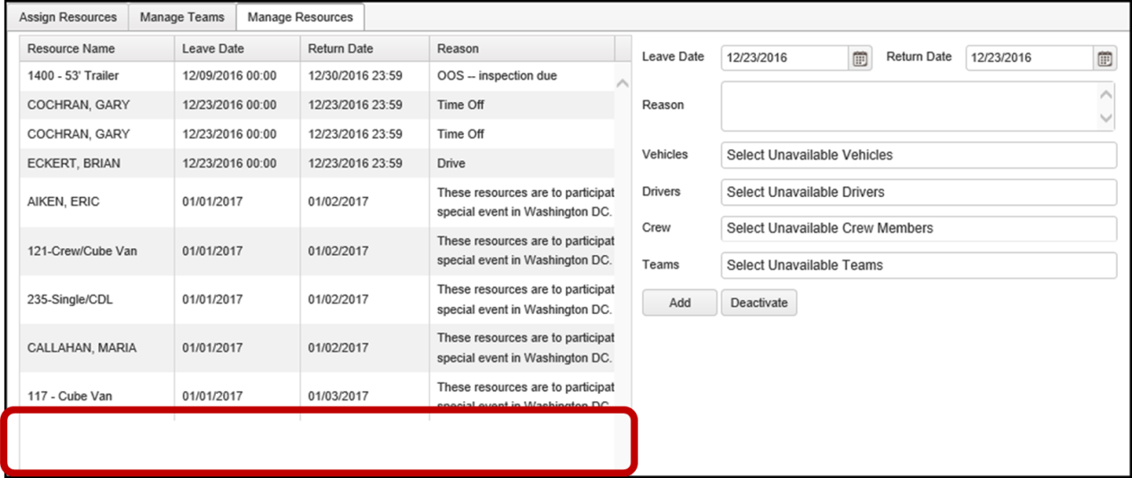

# Service Activity Management

## Navigate to View/Edit a Service Activity

It is assumed that you are already in the Local Dispatch application.

### Locate Desired Service Activity

1. Locate the Selection Criteria panel.
2. Select the “View” value.
3. Select the “Date” value.
4. Select the “Refresh” button.

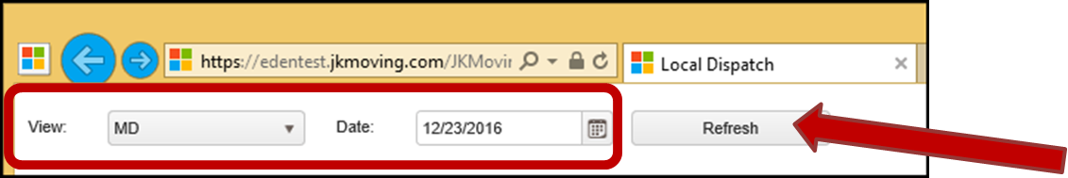

1. The Service Activities that meet the selection criteria will display in the “Service Activities” panel.

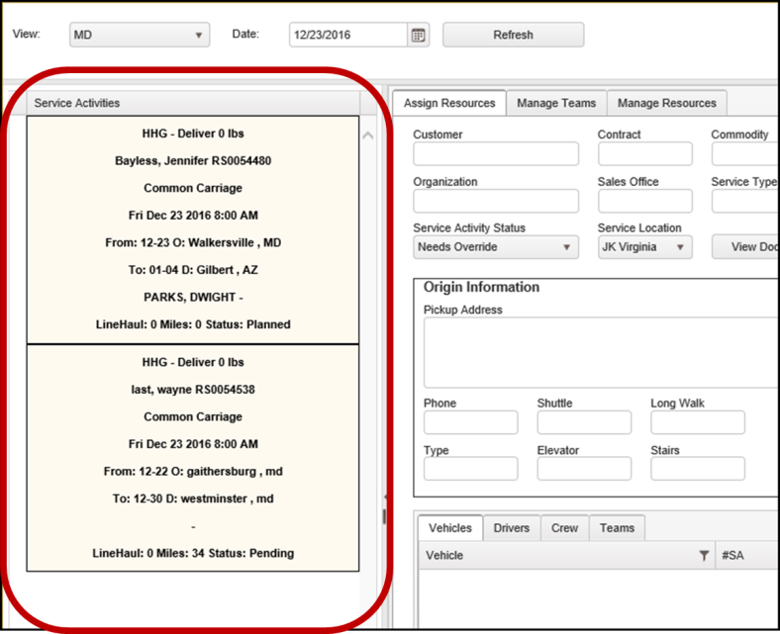

### Select Desired Service Activity

1. Click on the desired Service Activity to select it.
2. Note that an orange highlight will appear next to the Service Activity selected in the Service Activities panel.
3. Also, note that the “Assign Resources” tab now contains information for the Service Activity selected.

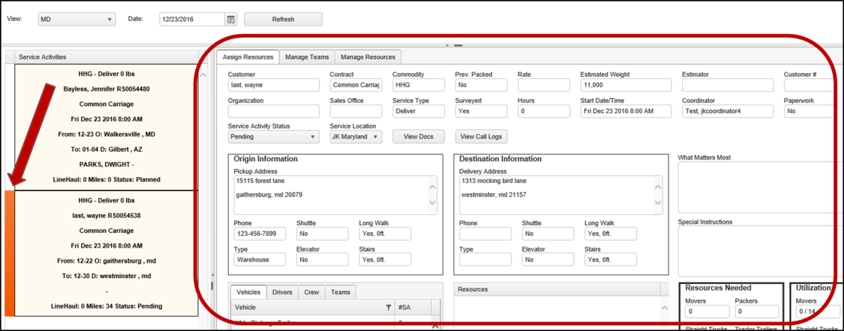

1. The selected Service Activity is now ready for editing.

## Edit Service Activity

It is assumed that you are already in Local Dispatch and have navigated to where you may view/edit a Service Activity.

1. Select the “Assign Resources” tab.
2. Select a “Service Activity Status” value.
   1. Options are:
      1. Needs Override
      2. Pending
      3. Planned
3. Select a “Service Location” value.
   1. Options are:
      1. JK Maryland
      2. JK Virginia
      3. Off Terminal
4. Enter text into the “What Matters Most” field.
5. Enter text into the “Special Instructions” field.

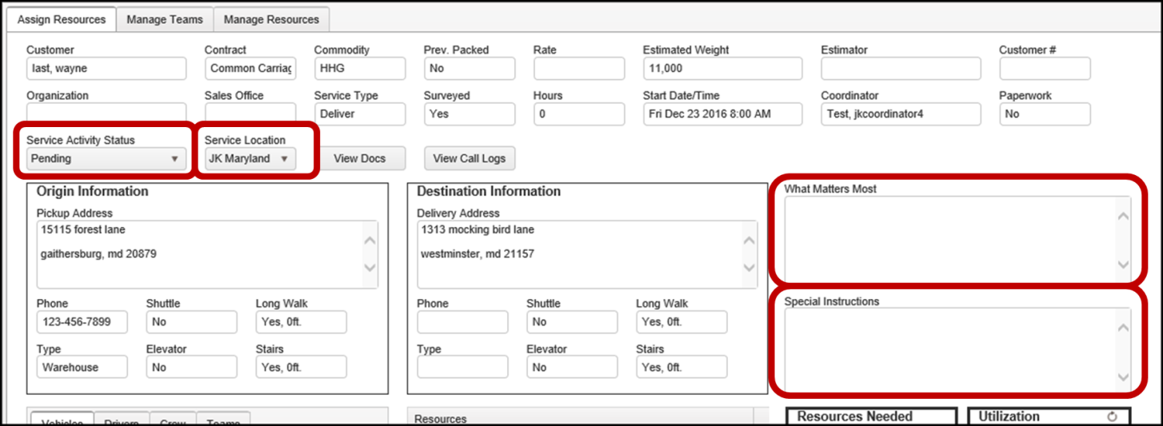

1. Select the “Update” button.
   1. This button is located in the lower right corner of the “Assign Resources” tab.



1. A confirmation window will display.
2. Select the “OK” button.

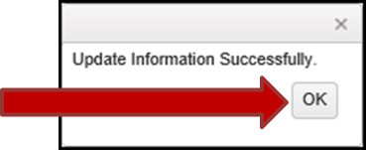

1. The edited fields are now saved.

## Add Resources to Service Activity

It is assumed that you are already in Local Dispatch and have navigated to where you may view/edit a Service Activity.

1. Select the “Assign Resources” tab.
2. Assign a Vehicle Resource.
   1. Select the “Vehicles” tab in the Available Resources panel.
   2. Locate the needed Vehicle to assign.

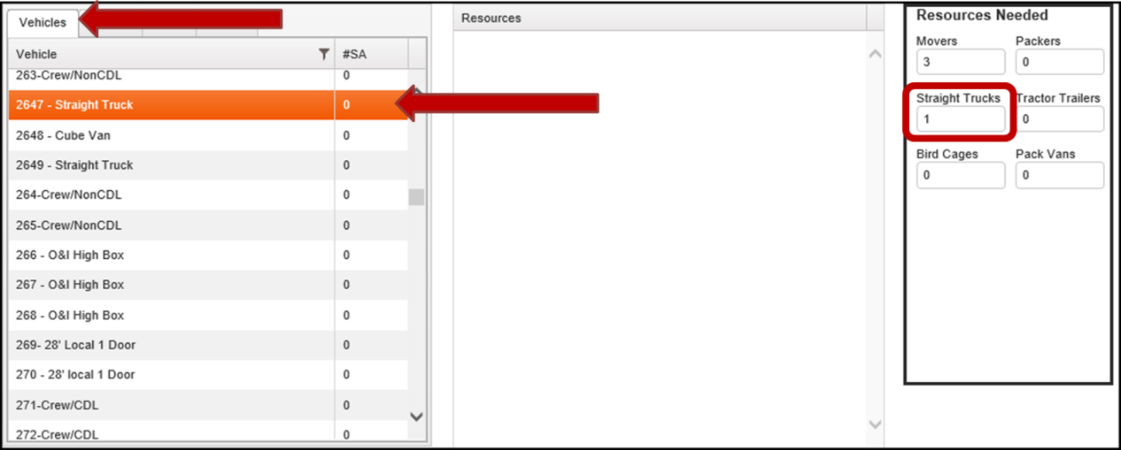

* 1. Double click on the desired Resource to add it to the Service Activity.
     1. **Note:** Adding of the Resources is done one-at-a-time.
     2. The added resource is now displayed in the Resource panel.
     3. The added Resource in the Available Resources panel now displays 1 #SA.
        1. #SA is the number of Service Activities the Resource is assigned to.
  2. The Service Activity in the “Service Activities” panel now displays the primary Vehicle.
  3. The Vehicle Resource is now completed and saved.

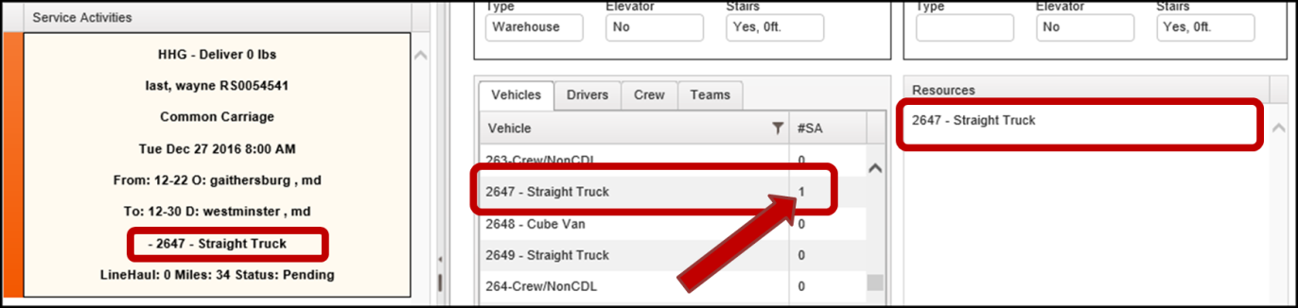

1. Assign a Driver Resource.
   1. Select the “Drivers” tab in the Available Resources panel.
   2. Locate the desired Driver.
   3. Double click on the desired Resource to add it to the Service Activity.
   4. The Service Activity in the “Service Activities” panel now displays the Drivers name.
   5. The Driver Resource is now completed and saved.

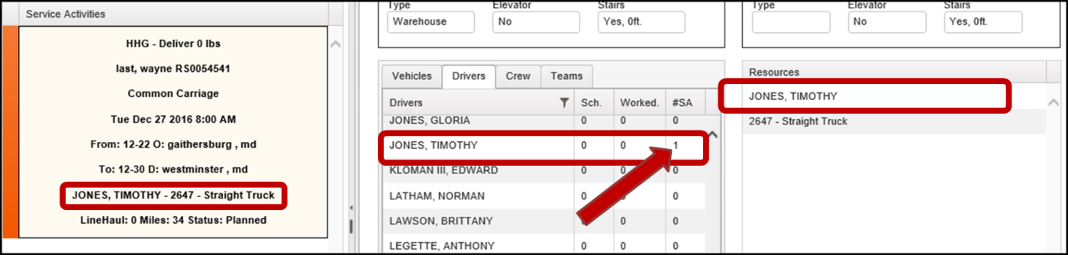

1. Assign Crew members.
   1. Select the “Crew” tab.
   2. Locate the desired Crew member.
   3. Double click on the desired Resource to add it to the Service Activity.
   4. The specific Crew member addition is now completed and saved.
   5. Repeat these steps for each Crew member to be added.

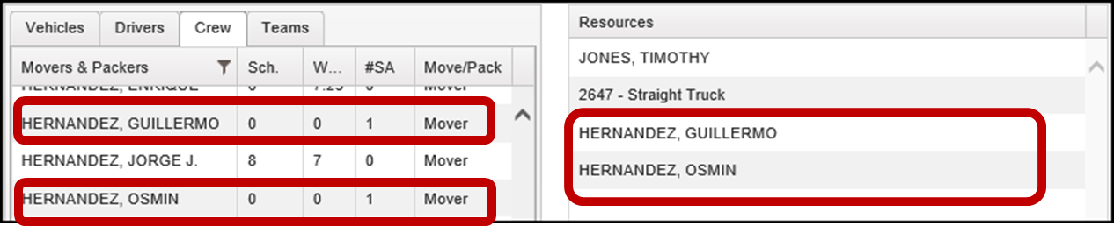

1. All Resources are now completed and saved.

## Remove Resource from Service Activity

It is assumed that you are already in Local Dispatch and have navigated to where you may view/edit a Service Activity.

1. Select the “Assign Resources” tab.
2. Remove a Resource.
   1. Locate the Resource to be removed in the Resources panel.

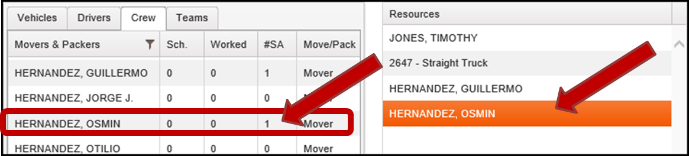

* 1. Double click on the Resource to be removed.

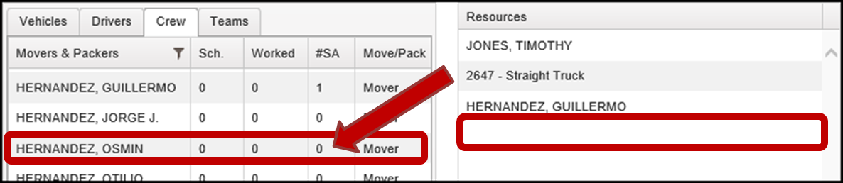

1. The Resource is now removed from the Service Activity.

## View and Add Call Logs

It is assumed that you are already in Local Dispatch and have navigated to where you may view/edit a Service Activity.

1. Select the “Assign Resources” tab.
2. Select the “View Call Logs” button.
3. The “Call Logs” window will display.

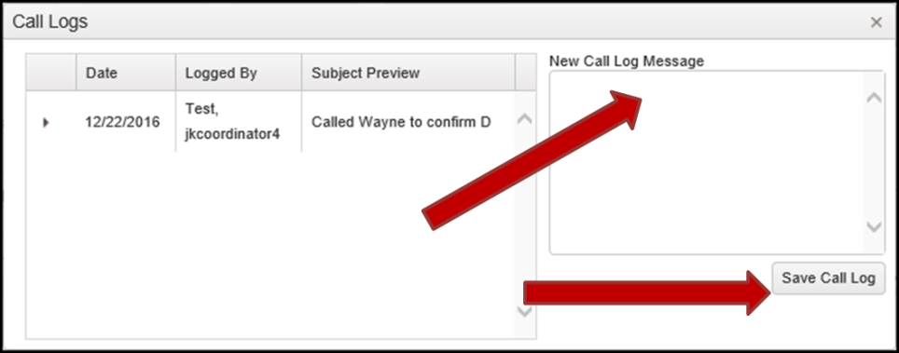

1. Enter text into the “New Call Log Message” field.
2. Select the “Save Call Log” button.
   1. The new call log will appear.
3. Select the expansion buttons. To the left of the Call Logs displayed.
   1. The full message content will be displayed.

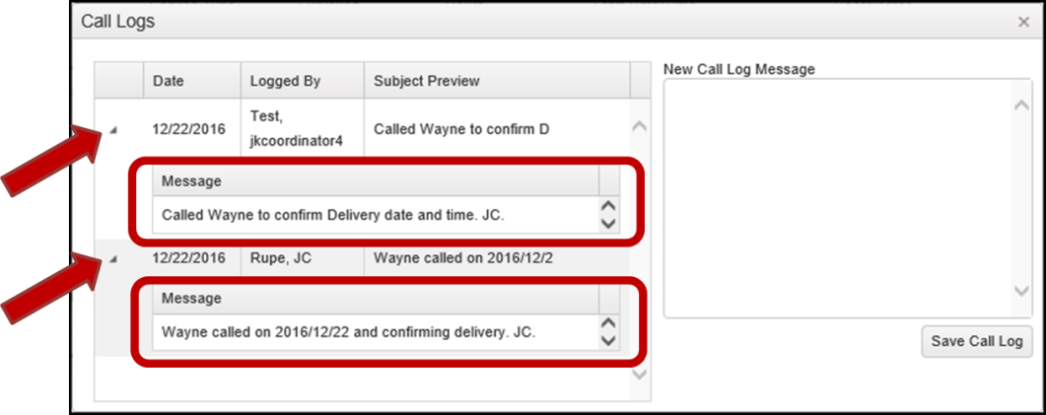

1. Close the “Call Logs” window.
   1. Select the “X” buttons in the upper right corner of the window.

## View Documents

It is assumed that you are already in Local Dispatch and have navigated to where you may view/edit a Service Activity.

1. Select the “Assign Resources” tab.
2. Select the “View Docs” button. 
3. The SharePoint window will display the Moves attached Documents.
   1. Use SharePoint to make any Document changes. (Such as adding docs, removing docs and editing docs.)

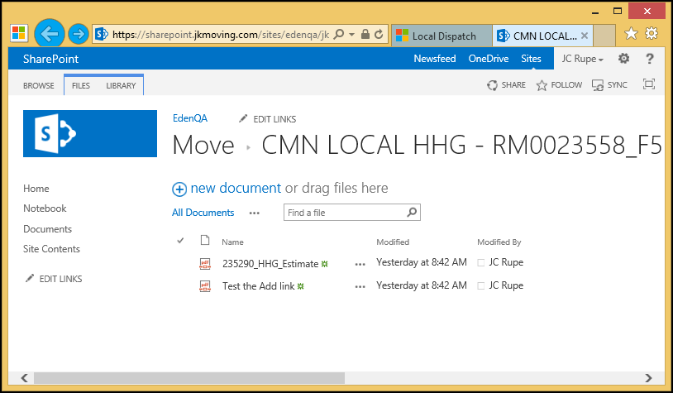

1. When finished, close the SharePoint window.
2. The Local Dispatch window should still be there.